Image Curation Plan

Keepers
Image | Source | Notes
Profile photo | Real capture | Headshot, natural light, neutral background. No AI enhancement or background replacement.
Portfolio hero screenshot | Real capture | Full-page screenshot of the FlyRank dashboard build. Cropped to show data table and chart, not the browser chrome.
Notebook output screenshot | Real capture | Cell output from w03_data_contract.ipynb showing grain check and feature frame. Proves the queries ran against real warehouse data.
Code snippet screenshot | Real capture | Clean screenshot of the leakage experiment code. Shows honest vs leaky model accuracy side by side.
Hero texture (background) | AI-generated | Subtle grid pattern in near-white (#F8F9FA) with faint blue lines. Generated in one style, kept consistent across pages.
Favicon | AI-generated | Simple "AS" monogram in Space Grotesk, accent blue (#2563EB). Generated once, used everywhere.

Rejected
AI-generated headshot: Generated three options with a "professional portrait, soft lighting" prompt. All three had the same smooth, airbrushed look that signals AI. A real photo with natural imperfections (slightly off-center framing, visible background noise) reads as more honest. Deleted all three.

Real capture vs AI: where I drew the line
Real photo for profile: The subject is a person. An AI portrait would raise the question "is this actually you?" and that doubt undermines trust.
Real screenshots for work: The whole point is showing what I built. A generated mockup of a dashboard I did not build is a lie dressed up as design.
AI for texture and favicon: These are decorative, not proof. A grid pattern does not need to be "real." Consistency matters more than authenticity here.

Profile photo (real capture):
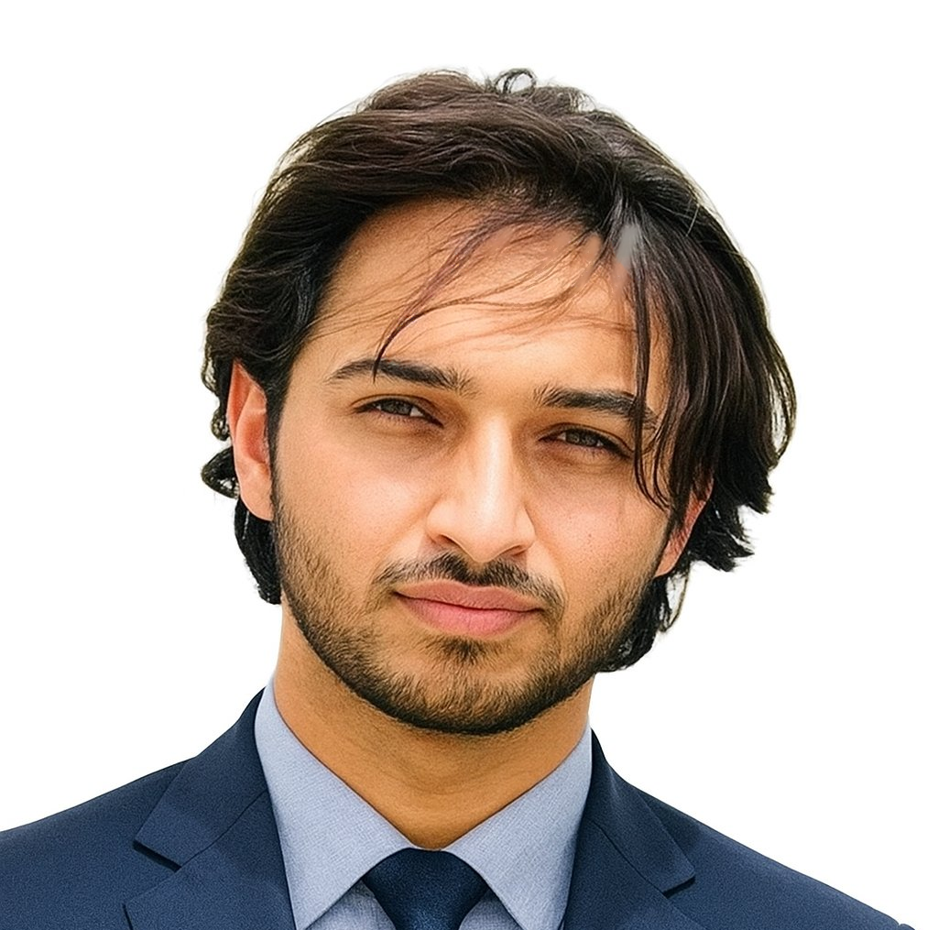
Dashboard screenshot (real capture):
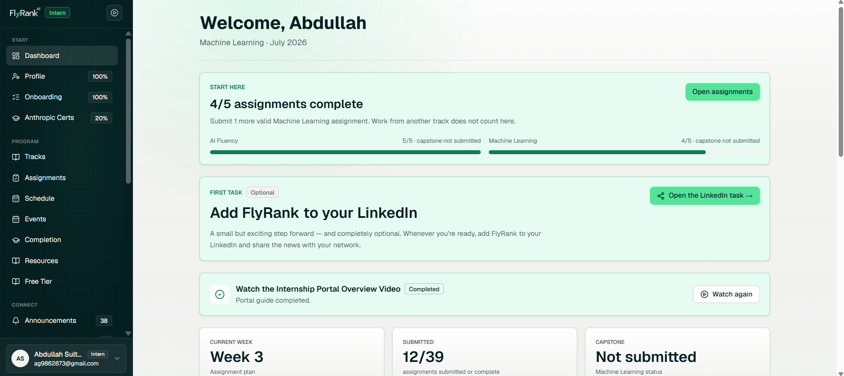
Grain check output (real capture):
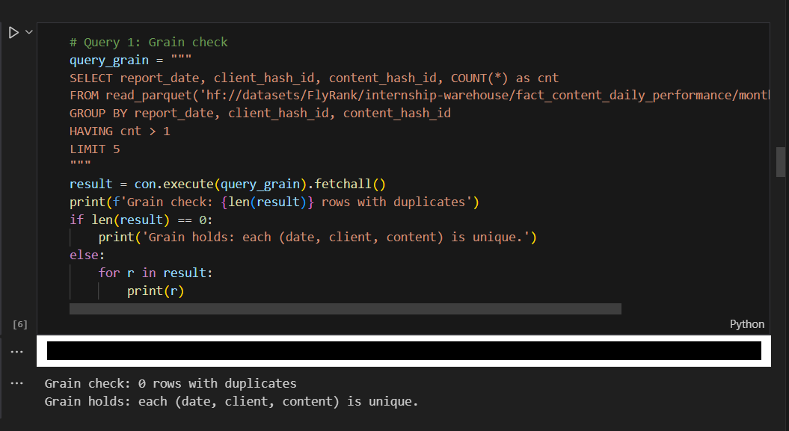
Feature frame output (real capture):
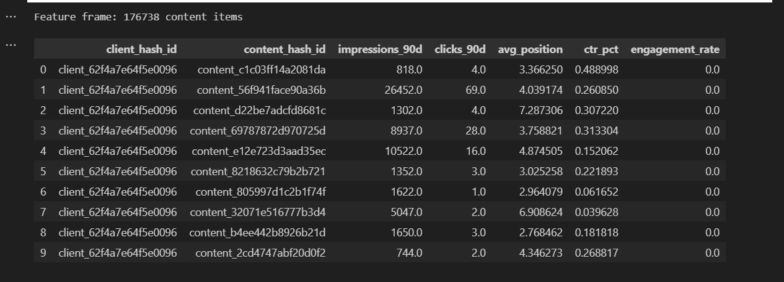
Leakage accuracy (real capture):
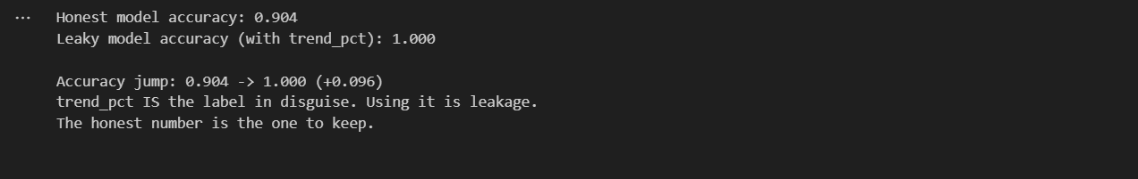
Notebook header (real capture):
